Boolean Algebra

Opening up a computer, a terminal, or practically any other “computerized” item reveals boards containing little black rectangles. These little black rectangles are the integrated circuit (IC) chips that perform the logic of the computer. Each IC can be represented by a Boolean Algebra equation, and vice versa. The representation that is used depends on the context. Boolean Algebra provides a convenient representation and notation for simplifying and solving equations. Digital Electronics provides a layout that can then be implemented with IC chips.

The operators used in these categories are listed in the description of the Digital Electronics category. The logic gates are usually used in Digital Electronics questions; the algebraic equations, symbols and truth tables, in Boolean Algebra. Of course, it is crucial to be able to translate between a digital electronics circuit and its Boolean Algebra notation. The order of operator precedence is NOT; AND and NAND; XOR and EQUIV; OR and NOR. Binary operators with the same level of precedence are evaluated from left to right.

References

Handbooks for building circuits using IC are available in most electronics and home computer stores. These contain many example circuits. A formal description of the material can be found in textbooks covering discrete mathematics, finite mathematics and compute hardware and architecture. Example texts include:

Lipschutz, Seymour. Essential Computer Mathematics – Shaum’s Outline Series, McGraw Hill (1982), Chapters 6, 7 and 8.

Mano, M. Morris. Digital Logic and Computer Design, Prentice-Hall (1979).

Preparata, Franco P. Introduction to Computer Engineering, Harper & Row (1985).

Boolean Algebra Identities

1. 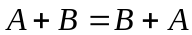 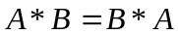 (Communicative Property)
2. 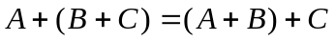 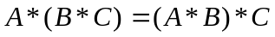 (Associative Property)
3. 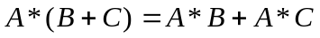 (Distributive Property)
4. 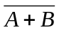= 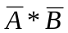 (DeMorgan’s Law)
5. 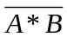 = 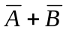 (DeMorgan’s Law)
6. 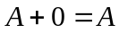 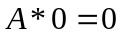
7. 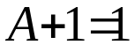 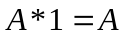
8. 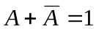 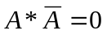
9. 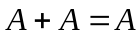 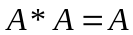
10. 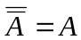

11. 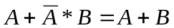
12. 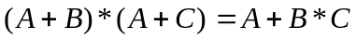
13.
14. 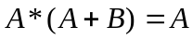
15. 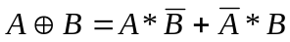
16. 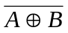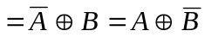

Sample Programs

Simplify the following expression as much as possible:  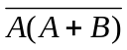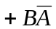 | Using various elementary identities, the expression simplifies as follows:  = 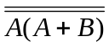*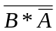  =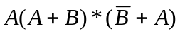  = 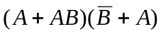  =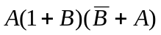  =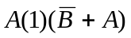  =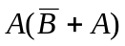  =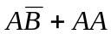  =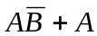  =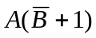  =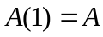
Find all ordered pairs (A, B) that make the following expression TRUE.  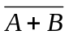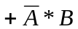 | = (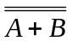)(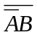)  = (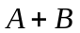)(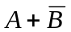)  = 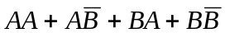  = 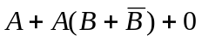  =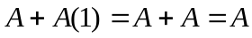  This yields the solutions (1, 0) and (1, 1). This problem, like most Boolean Algebra problems, could also be solved by drawing a truth table with the following seven column headings: A, B, A+B,  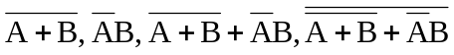.
Simplify the following expression to one that uses only two operators.  (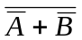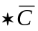) + (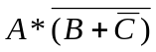) | The evaluation is as follows:  () + ()  = (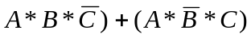  = 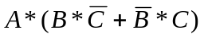  = 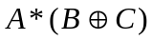  To realize this equation as a circuit, two gates are used: an XOR (input is B and C) and an AND (inputs are A and the output of the XOR gate). The output of the AND is the output of the circuit.

